HDMI 1*2 Splitter

USER MANUAL

1. Description
The HDMI splitter divides one high-definition video source into two high-definition video signals, and supports automatic matching of EDID. When connected to speakers or headphones, the audio part of the EDID output is stereo. The device has excellent image processing and transmission capabilities, which makes the distributed signal more smooth and stable. It is a reliable, high-performance and efficient HDMI signal distribution method.

2. Features
- Divide the high definition video source into two high definition video signals;
- High definition video signal resolution up to 3840 * 2160 @ 30 Hz;
- Compliance with HDMI 1.4;
- Comply with HDCP 1.4 standard-high-bandwidth digital content protection technology;
- Automatically match the EDID, when the speaker or earphone is connected, the EDID output of the audio part is stereo;
- High compatibility, can auto-match source and display device;
- Built-in automatic adjustment system, make the image smooth, clear and stable;
- Simple to install, plug and play;

3. Package list
1 pc
1 pc
1 pc
1 pc

- HDMI 1*2 splitter host
- micro USB power cord
- User manual
- Warranty Card
4. Specifications

Parameter |  | Description
Video | Standards | HDMI 1.4; HDCP 1.4
Video | Maximum pixel clock | 225MHz
Video | Maximum data rate | 10.2Gbps
Video | Resolution | Max 3840*2160@30Hz
Video | Connector | HDMI-A
Video | Impedance | 100Ω
Video | Recommended maximum input/output distance for HDMI. | Less than 5 meters, at 1920x1080@60hz.
Other | Power supply | The power adapter: DC 5V
Other | Power dissipation | MAX 2W
Other | Temperature | Operating: -5℃ ~ +70℃
Other | Humidity | Operating: 5% ~ 90%
Other | Dimension | 64*62*14mm
Other | The warranty | 1 year free warranty

5. Panel
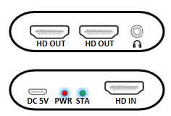

Port name | Description
HD IN/HD OUT | HDMI signal input/output.
DC 5V | Power input.
 | Stereo audio output.
LED indicator | Description
PWR | Power indicator light
STA | Video source signal indicator light

6. Installation

- Connect the HDMI signal source to the HD IN of the HDMI1*2 splitter,
- Connect display devices (such as high-definition TVs, splicing screens, etc.) to HD OUT1-HD OUT2,
- Connect Audio output audio to audio equipment,
- Connect the HDMI1*2 splitter to the power supply. When the indicator lights up normally, the system runs normally.

7. Diagram
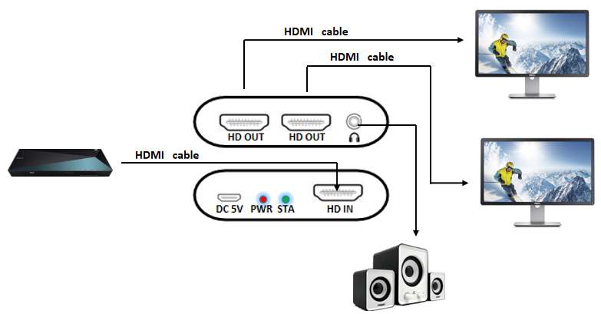

8. Warranty
Please keep the user manual in a place where safety and easy to find so that you can read it immediately when meet problems.
safety instruction:
- Please do not disassemble this product by yourself because it doesn't including DIY function.
- Please don't make the product touch water in case damaged, because it is Not waterproof design.
- Please use dry cloth material when clean the product surface.
- Please do not use this product in the environment of too wet or too high temperature.
- Please avoid contact with corrosive substances.
- When there is damage or other physical damage to the product, please stop using and contact with customer service to get support.

