HDMI USB 16*1 SWITCH
USER MANUAL

1. Description
HDMI KVM switch sixteen groups of high-definition Audio and video source and USB interface implementation free switch, Adaptive EDID , can adapt to a variety of complex application environments.The equipment has excellent image processing and transmission capacity, make the output signal is more smooth and steady, is a reliable, high performance and efficient way of HDMI USB switch

- Features
- The sixteen-way HD Audio and video source choose USB interface to realize sixteen free switch;
- Support HDMI 1.4 standard protocol;
- Support video resolution max up to 4Kx2K@30Hz；
- Support USB 2.0 standard protocol;
- Adaptive EDID , able to adapt to a variety of complex application environment;
- Support Hot key switch, convenient and quick(ctrl + ctrl + 1,2,3……14,15,16 + Enter)
- High compatibility, can auto-match source and display device;
- Built-in automatic adjustment system, make the image smooth, clear and stable;
- Simple to install, plug and play;

3. Package list
        - HDMI KVM16*1Switcher host 1 pcs
        - USB Cable 16 pcs
        - HDMI Cable 16 pcs
        - Hardware accessories 2 pcs
        - Power adapter 1 pcs
        - user manual 1 pcs
        - Warranty Card 1 pcs
        - Foot Pad . 8 pcs

4. Specifications
Parameter |  | Description
Video | Standards | HDMI 1.4
Video | Maximum pixel clock | 225MHz
Video | Maximum data rate | 10.2Gbps
Video | Resolution range | Up to 4Kx2K@30Hz, 3D, 1920*1080@60Hz
Video | Connector | HDMI-A Interface
Video | Impedance | 100Ω
Video | HDMI Cable Range | <5M( Resolution: 1920*1080@60Hz)
USB | Interface protocols | USB1.1(2 pcs), USB 2.0(2 pcs)
USB | PC input interface type | USB-B
USB | Output interface type | USB-A
Other | Power supply | The power adapter: DC 12V
Other | Power dissipation | MAX 5W
Other | Temperature | Operating: -5℃ ~ +70℃
Other | Humidity | Operating: 5% ~ 90%
Other | Dimension | 445*95*42mm
Other | The warranty | 1 year free warranty
5.Panel

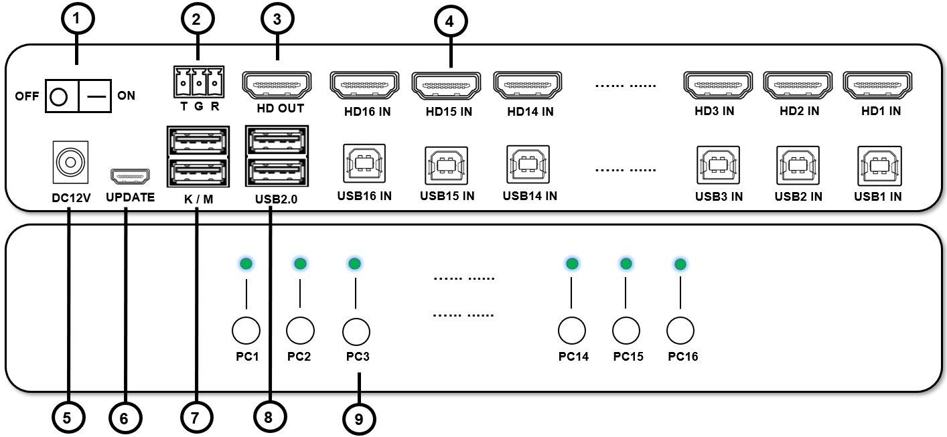

Index | Description
1 | Power switch
2 | RS232 interface
3 | HDMI video output signal
4 | PC1, PC2，PC3，PC4，PC5，PC6，PC7，PC8，PC9, PC10，PC11，PC12，PC13，PC14，PC15，PC16 HDMI and USB signal inputs
5 | 12V power supply input
6 | Data update interface
7 | USB keyboard mouse interface
8 | USB2.0 devices interface
9 | PC1, PC2，PC3，PC4，PC5，PC6，PC7，PC8，PC9, PC10，PC11，PC12，PC13，PC14，PC15，PC16 switch buttons and status indicators

6.Diagram

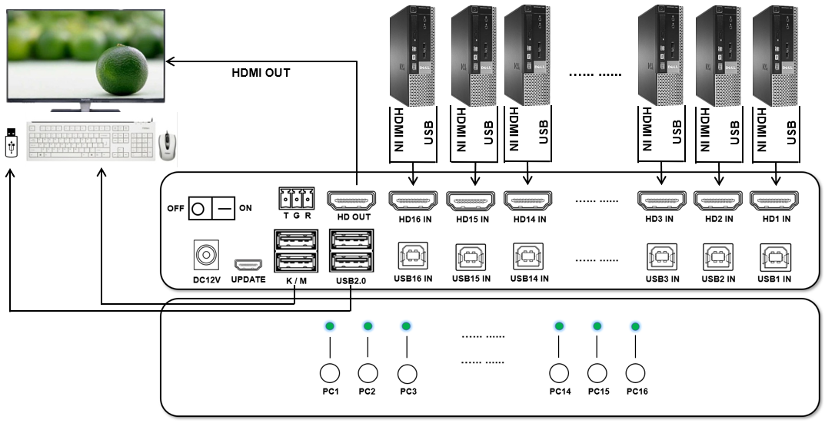

7.Serial command
Enter PS 1 to switch to port 1 (original keyboard command ctrl + ctrl +1)
Enter PS 2 to switch to port 2 (original keyboard command ctrl + ctrl + 2)
Enter PS 3 and switch to port 3 (original keyboard command ctrl + ctrl + 3)
Enter PS 6 to switch to port 4 (original keyboard command ctrl + ctrl + 6)
Enter PS 7 to switch to port 15 (original keyboard command ctrl + ctrl + 7)
Enter PS 8 to switch to port 16 (original keyboard command ctrl + ctrl + 8)
Enter CS 0 to stop scanning (no keyboard command, any key)
Enter CS 1 to start scanning (original keyboard command ctrl + ctrl +S)

You need to add ENTER at the end, and there must be a space before the number (except for hexadecimal commands)

8. Warranty
Please keep the user manual in a place where safety and easy to find so that you can read it immediately when meet problems.
safety instruction:
- Please do not disassemble this product by yourself because it doesn't including DIY function.
- Please don't make the product touch water in case damaged, because it is Not waterproof design.
- Please use dry cloth material when clean the product surface.
- Please do not use this product in the environment of too wet or too high temperature.
- Please avoid contact with corrosive substances.
- When there is damage or other physical damage to the product, please stop using and contact with customer service to get support.

