HDMI KVM 4*1 DUAL DISPLAY SWITCH
USER MANUAL

1. Description
HDMI KVM switch four groups of high-definition Audio and video source and USB interface implementation free switch, Adaptive EDID, can adapt to a variety of complex application environments. The equipment has excellent image processing and transmission capacity, make the output signal is more smooth and steady, is a reliable, high performance and efficient way of HDMI USB switch.

- Features
- The four groups of HD audio ,video source and USB interface choose to four free switch;
- Support video resolution max up to 3840x2160@30Hz;
- Compliance with HDMI 1.4 and HDCP 1.2 standard;
- Support USB2.0 protocol;
- Adaptive EDID , able to adapt to a variety of complex application environment;
- Support hot key switch (Scroll Lock + Scroll Lock + 1,2,3,4) or (Ctrl + Ctrl + 1,2,3,4).
- When the Ctrl commands conflict, you can enter (Ctrl + Ctrl + C + T + R + L + 0 ) Disable, to re-enable the Ctrl hotkey command, you need to enter (Scroll Lock + Scroll Lock + C + T + R + L + 1).High compatibility, can auto-match source and display device.
- High compatibility, can auto-match source and display device;
- Built-in automatic adjustment system, make the image smooth, clear and stable;
- Built-in ESD protection system;
- Easy to install, plug and play;

3. Package list
        - HDMI KVM4*1Switcher host 1 pcs
        - USB Cable 4 pcs
        - HDMI Cable 8 pcs
        - Micro USB Cable 1 pcs
        - User manual 1 pcs
        - Foot Pad .. 4 pcs

4. Specifications
Parameter |  | Description
Video | Standards | HDMI 1.4
Video | Maximum pixel clock | 225MHz
Video | Maximum data rate | 10.2Gbps
Video | Resolution range | Up to 3840x2160@30Hz, 1920*1080@60Hz
Video | Connector | HDMI-A Interface
Video | Impedance | 100Ω
Video | HDMI Cable Range | <5M( Resolution: 1920*1080@60Hz)
USB | Interface protocols | USB1.1(2 pcs), USB2.0(2pcs)
USB | PC input interface type | USB-B
USB | Output interface type | USB-A
Other | Power supply | USB-B 5V power supply
Other | Power dissipation | MAX 7W
Other | Temperature | Operating: -5℃ ~ +70℃
Other | Humidity | Operating: 5% ~ 90%
Other | Dimension | 202*75*27mm
Other | The warranty | 1 year free warranty

5. Panel
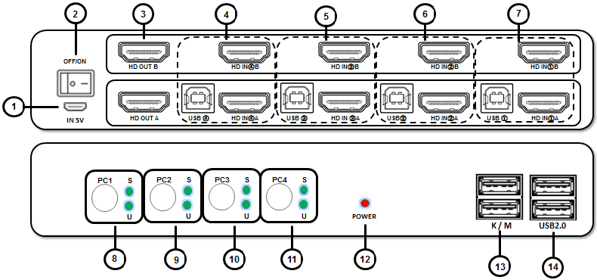

Port name | Description
1 | 5V power supply , for high power USB device
2 | switch
3 | HDMI video output signal
4~7 | PC1 , PC2，PC3，PC4 groups HDMI USB input
8~11 | PC1 , PC2，PC3，PC4 groups buttons and status indicators
12 | Power indicators
13 | USB keyboard mouse connectors
14 | USB2.0 device connectors

6. Diagram

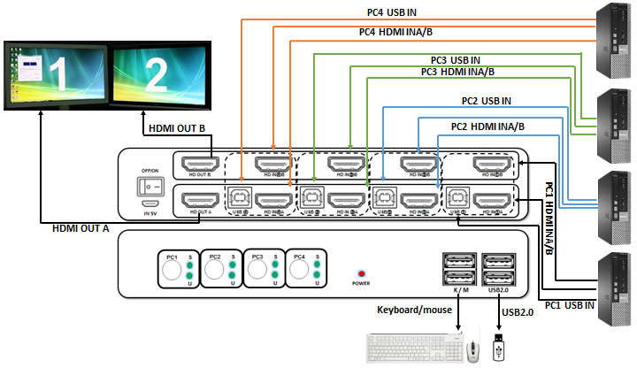

7. Warranty
Please keep the user manual in a place where safety and easy to find so that you can read it immediately when meet problems.
safety instruction:
- Please do not disassemble this product by yourself because it doesn't including DIY function.
- Please don't make the product touch water in case damaged, because it is Not waterproof design.
- Please use dry cloth material when clean the product surface.
- Please do not use this product in the environment of too wet or too high temperature.
- Please avoid contact with corrosive substances.
- When there is damage or other physical damage to the product, please stop using and contact with customer service to get support.

