HDMI USB 2*1 SWITCH
USER MANUAL

1. Description
HDMI KVM switch two groups of high-definition Audio and video source and USB interface implementation free switch, Adaptive EDID , can adapt to a variety of complex application environments.The equipment has excellent image processing and transmission capacity, make the output signal more smooth and steady, it is a reliable, high performance and efficient way of HDMI USB switch.

2. Features
- 2 ports KVM switch HDMI,2CH HDMI and USB HID signals synchronize switch.
- Support HDMI 2.0, HDCP2.2 standards.
- Support USB1.1 and USB2.0 protocol.
- Support hot key switch (Scroll Lock + Scroll Lock + 1, 2) or (Ctrl + Ctrl + 1, 2).
- When the Ctrl commands conflict, you can enter (Ctrl + Ctrl + C + T + R + L + 0 ) Disable, to re-enable the Ctrl hotkey command, you need to enter (Scroll Lock + Scroll Lock + C + T + R + L + 1).High compatibility, can auto-match source and display device.
- Support video resolution max up to 3840*2160@60Hz.
- Adaptive EDID , able to adapt to a variety of complex application environment.
- Built-in automatic adjustment system, make the image smooth, clear and stable.
- Simple to install, plug and play.

- Package list

HDMI KVM2*1 Switcher host | 1 pcs
USB A-B Cable | 2 pcs
HDMI 2.0 Cable | 2 pcs
Micro USB Cable | 1 pcs
User manual+Warranty Card | 1 set
Foot Pad | 4 pcs
4. Specifications
Parameter |  | Description
Video | Standards | HDMI 2.0
Video | Maximum pixel clock | 340MHz
Video | Maximum data rate | 18Gbps
Video | Maximum resolution | 3840*2160@60Hz, Backward compatible
Video | Connector | HDMI-A Interface
Video | Impedance | 100Ω
Video | HDMI Cable Range | <5M( Resolution: 1920*1080@60Hz)
USB | Interface protocols | USB2.0+USB1.1
USB | PC input interface type | USB-B
USB | Output interface type | USB-A
Other | Power supply | 5V power supply
Other | Power dissipation | MAX 2W
Other | Temperature | Operating: -5℃ ~ +70℃
Other | Humidity | Operating: 5% ~ 90%
Other | Dimension | 130*76*26.5mm
Other | The warranty | 1 year free warranty
5. Panel
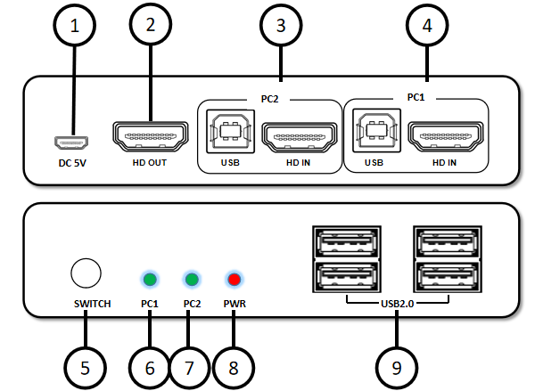

Port name | Description
1 | 5V power supply input port
2 | HDMI video output signal
3、4 | PC2、PC1 group HDMI USB input
5 | PC1, PC2 switch buttons
6、7 | PC1, PC2 status indicators
8 | Power indicators
9 | Keyboard & Mouse、USB2.0 device input

6.Diagram

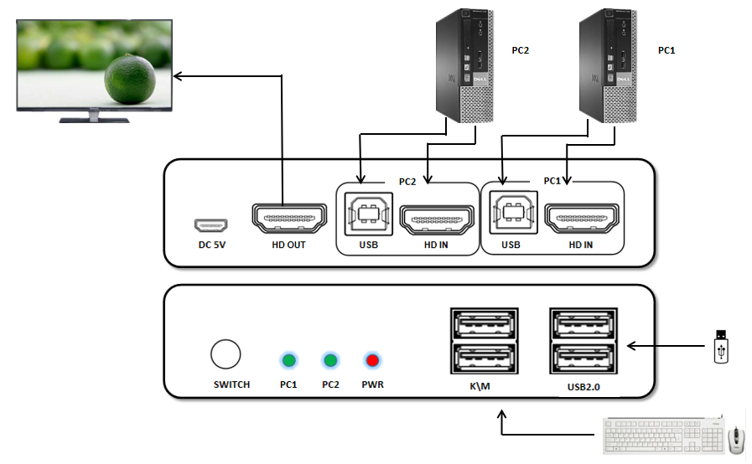

7. Warranty
Please keep the user manual in a place where safety and easy to find so that you can read it immediately when meet problems。
safety instruction:
- Please do not disassemble this product by yourself because it doesn't including DIY function.
- Please don't make the product touch water in case damaged,because it is Not waterproof design.
- Please use dry cloth material when clean the product surface.
- Please do not use this product in the environment of too wet or too high temperature.
- Please avoid contact with corrosive substances.
- When there is damage or other physical damage to the product,please stop using and contact with customer service to get support.

