HDMI KVM 4*1 SWITCH
USER MANUAL

1. Description
HDMI KVM switch four groups of high-definition Audio and video source and USB interface implementation free switch, Adaptive EDID, can adapt to a variety of complex application environments. The equipment has excellent image processing and transmission capacity, make the output signal more smooth and steady, it is a reliable, high performance and efficient way of HDMI USB switch.

- Features

- 4 ports KVM switch HDMI, 4CH HDMI and USB HID signals synchronize switch.
- Support HDMI 2.0, HDCP 2.2 standards.
- Supports video resolution max up to 3840*2160@60Hz.
- Support HDMI dual display (this function is only available on computers that support dual display).
- Adaptive EDID , able to adapt to a variety of complex application environment.
- Support hot key switch(Scroll Lock + Scroll Lock + 1、2、3、4) or (Ctrl +Ctrl + 1、2、3、4).
- When the Ctrl commands conflict, you can enter (Ctrl + Ctrl + C + T + R + L + 0 ) Disable, to re-enable the Ctrl hotkey command, you need to enter (Scroll Lock + Scroll Lock + C + T + R + L + 1). High compatibility, can auto-match source and display device.
- High compatibility, can auto-match source and display device.
- Built-in automatic adjustment system, make the image smooth, clear and stable.
- Easy to install, plug and play.

3. Package list
HDMI KVM 4*1 Switcher Host | 1 Pc
USB A-B Cable | 4 Pcs
HDMI Cable | 8 Pcs
Micro USB Cable | 1 Pc
User Manual+Warranty Card | 1 Pc
Foot Pad | 4 Pcs

4. Specifications
Parameter |  | Description
Video | Standards | HDMI 2.0
Video | Maximum pixel clock | 340MHz
Video | Maximum data rate | 18Gbps
Video | Maximum resolution | 3840*2160@60Hz, Backward compatible
Video | Connector | HDMI-A Interface
Video | Impedance | 100Ω
Video | HDMI Cable Range | <5M( Resolution: 1920*1080@60Hz)
USB | Interface protocols | USB1.+USB2.0
USB | PC input interface type | USB-B
USB | Output interface type | USB-A
Other | Power supply | 5V power supply
Other | Power dissipation | MAX 2.5W
Other | Temperature | Operating: -5℃ ~ +70℃
Other | Humidity | Operating: 5% ~ 90%
Other | Dimension | 202*76*27mm
Other | The warranty | 1 year free warranty

- Panel

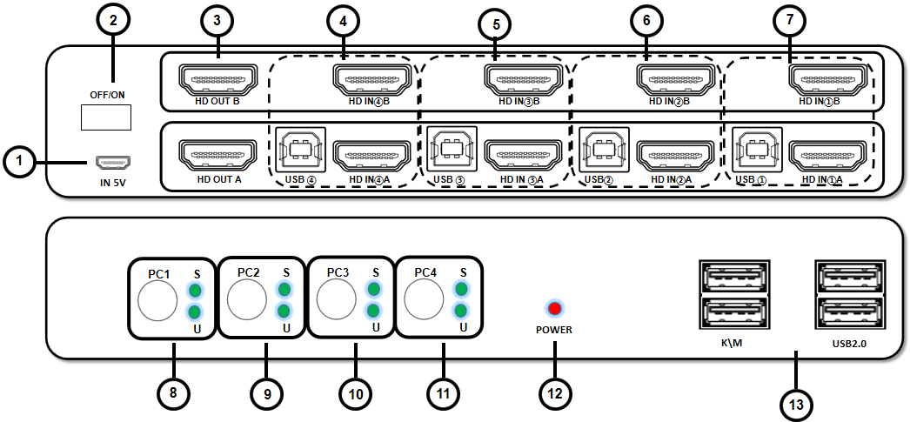

Port name | Description
1 | 5V power supply , for high power USB device
2 | Machine power switch
3 | HDMI video output
4~7 | PC1 , PC2，PC3，PC4 HDMI USB input
8~11 | PC1 , PC2，PC3，PC4 buttons and status indicators
12 | Power indicator
13 | Keyboard & Mouse

- Diagram

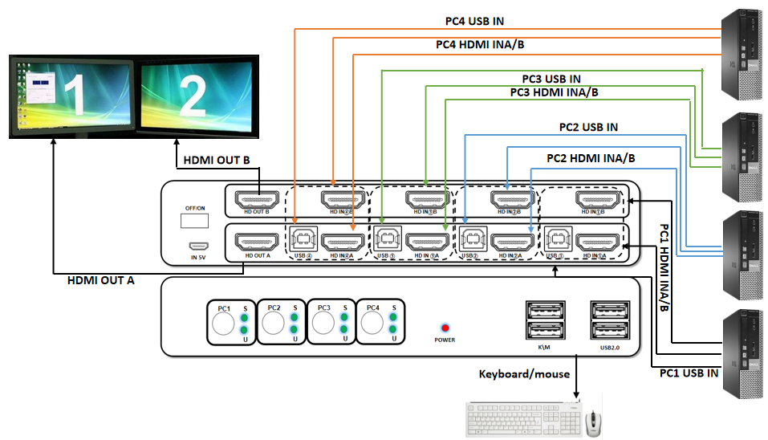

- Warranty
1. Connect HDMI/DVI/VGA/DP/Type-C to HDMI cables and USB-B cable between your computer 1 to 4 and "PC1 to PC4" on KVM.
2. Connect the HDMI output port on the KVM to your monitors with HDMI to HDMI/DVI/VGA/DP cables.
3. Connect the mouse and keyboard to the "K\M" port.
4. Turn on the power switch.

- Warranty
Please keep the user manual in a place where safety and easy to find so that you can read it immediately when meet problems.
safety instruction:
- Please do not disassemble this product by yourself because it doesn't including DIY function.
- Please don't make the product touch water in case damaged, because it is Not waterproof design.
- Please use dry cloth material when clean the product surface.
- Please do not use this product in the environment of too wet or too high temperature.
- Please avoid contact with corrosive substances.
- When there is damage or other physical damage to the product, please stop using and contact with customer service to get support.

