USB 2*4 SWITCH
USER MANUAL

- Description
USB switches enable two sets of USB interfaces to implement a free switch from two to the other. Support standard USB3.1 gen1, can adapt to a variety of complex application environments. It is a reliable, high-performance and efficient USB handover mode.

2. Features
- Two USB interfaces are selected from the two to switch freely.
- Compatible with USB3.1 gen1 standard;
- Automatic adaptation, can adapt to a variety of complex application environment;
- Key switch, convenient and fast;
- Built-in ESD electrostatic protection circuit, omnidirectional protection system security;
- Simple and convenient installation, plug and play, no need to set up;

3.Package list
        - USB2*4 Switcher host 1 pcs
        - USB Cable 2 pcs
        - Micro USB cable 1 pcs
        - User manual 1 pcs

- Specifications

Parameter |  | Description
USB | Interface protocols | USB3.1 gen1
USB | PC input interface type | USB-A
USB | Output interface type | USB-A
Other | Power supply | The power adapter: DC 5V
Other | Power dissipation | MAX 2W
Other | Temperature | Operating: -5℃ ~ +70℃
Other | Humidity | Operating: 5% ~ 90%
Other | Dimension | 104*48*14mm
Other | The warranty | 1 year free warranty
5. Panel
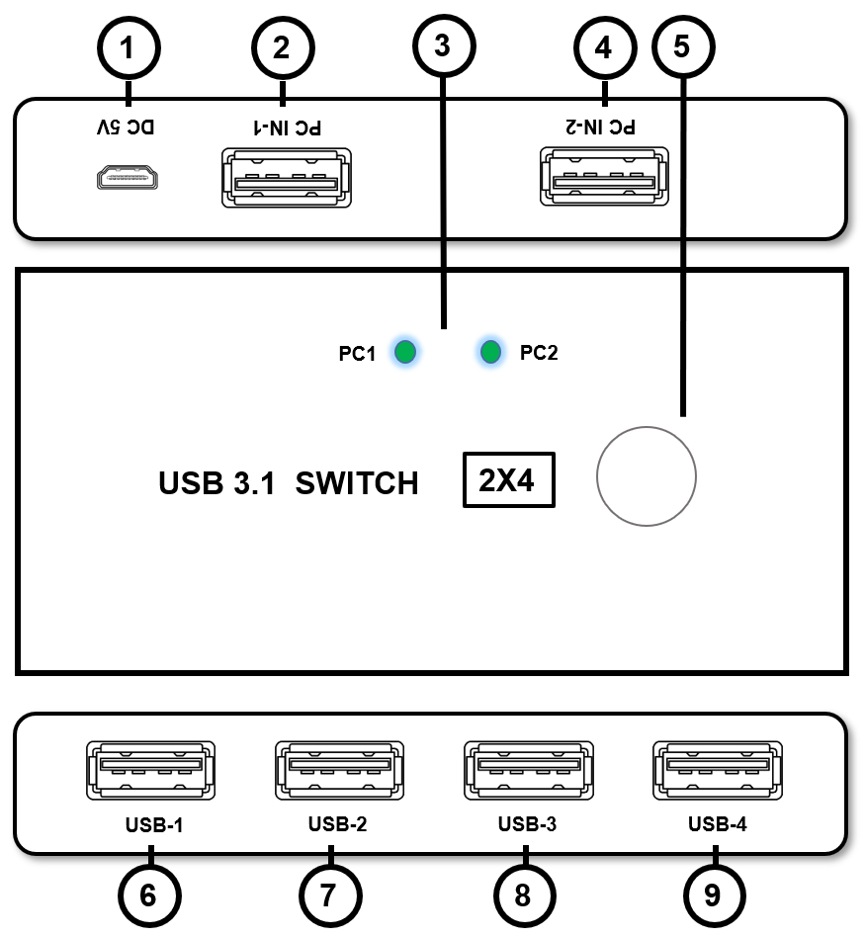

Port name | Description
1 | 5V power supply input port
2/4 | PC USB input
3 | USB input light
5 | USB switch key
6/7/8/9 | USB output

6.Diagram
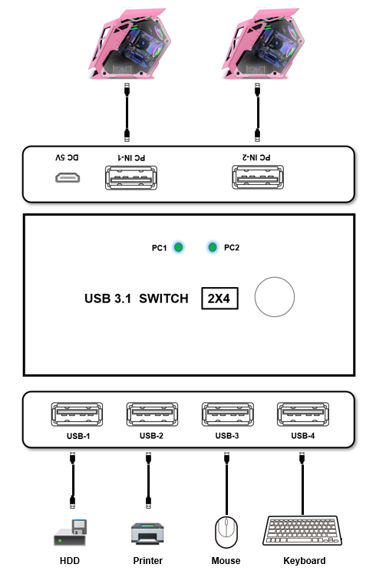

7. Warranty

Please keep the user manual in a place where safety and easy to find so that you can read it immediately when meet problems.
safety instruction:
- Please do not disassemble this product by yourself because it doesn't including DIY function.
- Please don't make the product touch water in case damaged, because it is Not waterproof design.
- Please use dry cloth material when clean the product surface.
- Please do not use this product in the environment of too wet or too high temperature.
- Please avoid contact with corrosive substances.
- When there is damage or other physical damage to the product, please stop using and contact with customer service to get support.

