HDMI USB 8*1 SWITCH
USER MANUA

1. Description
HDMI KVM switch eight groups of high-definition Audio and video source and USB interface implementation free switch, Adaptive EDID, can adapt to a variety of complex application environments. The equipment has excellent image processing and transmission capacity, make the output signal is more smooth and steady, is a reliable, high performance and efficient way of HDMI USB switch.

- Features

- The 8 ports HD Audio and video source choose USB interface to realize eight free switch;
- Supports video resolution max up to 4Kx2K@30Hz；
- Compliance with HDMI 1.4 standard;
- Support USB2.0 standard;
- Support hot key switch (Scroll Lock + Scroll Lock + 1,2,3,4,5,6,7,8) or (Ctrl + Ctrl + 1,2,3,4,5,6,7,8).
- When the Ctrl commands conflict, you can enter (Ctrl + Ctrl + C + T + R + L + 0 ) Disable, to re-enable the Ctrl hotkey command, you need to enter (Scroll Lock + Scroll Lock + C + T + R + L + 1).High compatibility, can auto-match source and display device.
- Adaptive EDID , able to adapt to a variety of complex application environment;
- High compatibility, can auto-match source and display device;
- Built-in automatic adjustment system, make the image smooth, clear and stable;
- Easy to install, plug and play;

3. Package list

HDMI KVM8*1Switcher host | 1 pcs | USB-A to USB-B Cable | 8 pcs
HDMI Cable | 8 pcs | Hardware accessories | 2 pcs
RS232 terminal | 1 pcs | Power adapter | 1 pcs
User manual | 1 pcs | Warranty Card | 1 pcs
Foot Pad | 4 pcs

4. Specifications

Parameter |  | Description
Video | Standards | HDMI 1.4
Video | Maximum pixel clock | 225MHz
Video | Maximum data rate | 10.2Gbps
Video | Resolution range | Up to 4Kx2K@30Hz, 3D
Video | Connector | HDMI-A Interface
Video | Impedance | 100Ω
Video | HDMI Cable Range | <5M( Resolution: 1920*1080@60Hz)
USB | Interface protocols | USB1.1（2pcs）,USB2.0（2pcs）
USB | PC input interface type | USB-B
USB | Output interface type | USB-A
Other | Power supply | The power adapter: DC 12V
Other | Power dissipation | MAX 5.5W
Other | Temperature | Operating: -5℃ ~ +70℃
Other | Humidity | Operating: 5% ~ 90%
Other | Dimension | 202*68*36mm
Other | The warranty | 1 year free warranty

5.Panel

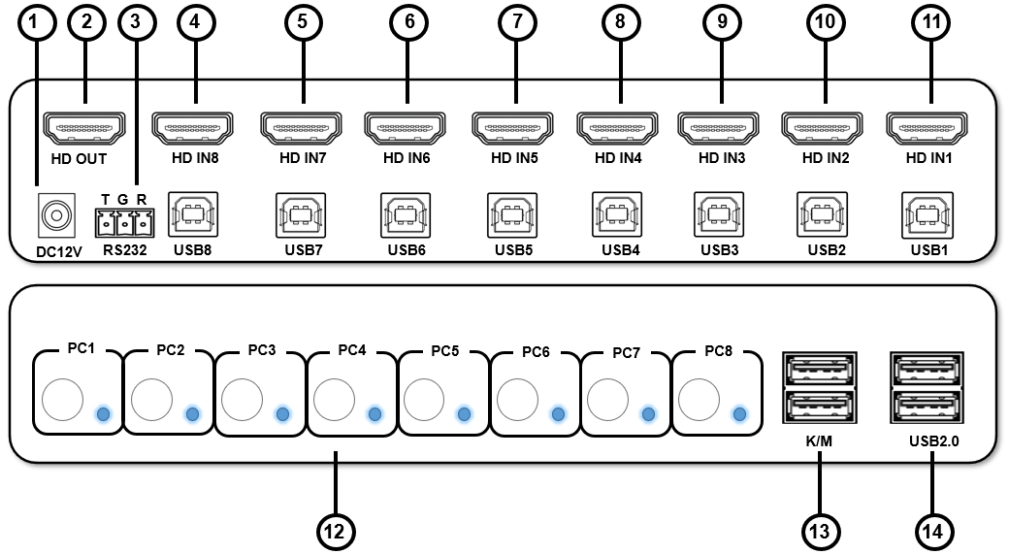

Port name | Description
1 | 12V power supply input port
2 | HDMI video signal output
3 | RS232 interface
4-11 | PC1-PC8 group HDMI USB input
12 | PC1, PC2，PC3，PC4，PC5，PC6，PC7，PC8， switch buttons and status indicators
13 | USB keyboard mouse connectors
14 | USB2.0 connectors

6.Diagram

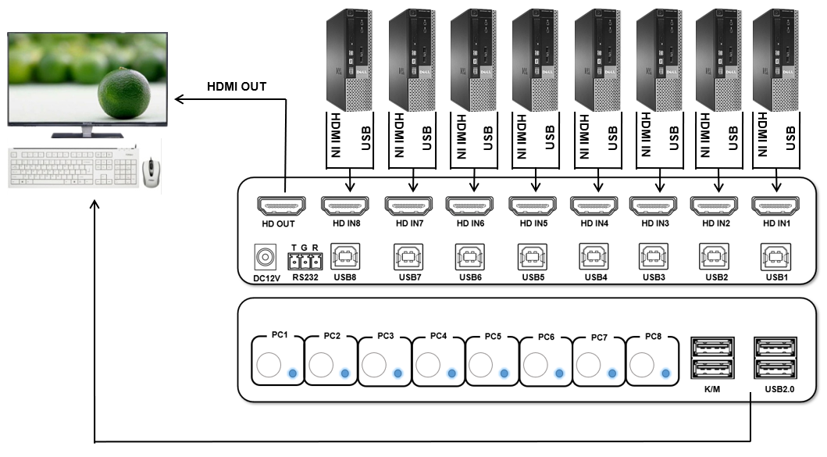

7. Warranty
Pease keep the user manual in a place where safety and easy to find so that you can read it immediately when meet problems.
safety instruction:
- Please do not disassemble this product by yourself because it doesn't including DIY function.
- Please don't make the product touch water in case damaged, because it is Not waterproof design.
- Please use dry cloth material when clean the product surface.
- Please do not use this product in the environment of too wet or too high temperature.
- Please avoid contact with corrosive substances.
- When there is damage or other physical damage to the product, please stop using and contact with customer service to get support.

