HDMI 1*4 SPLITTER Extender
USER MANUAL

1.Description
The HDMI extender provides extension of HDMI signals long distances over a single CAT6 cable, transform one channel input to 4 channels output, it supports high resolution up to 1080p. The extender can use for a wide range of applications requiring long distance transmission of high resolution with high quality by its good stability and powerful security.

2.Features
- Transmits 1 HDMI video and audio signals up to 50M over a single CAT6 cable;
- Support video resolution up to 1920*1080@60Hz, 3D signal;
- Transform one channel HDMI input to 4 channels Cat6 signal output;
- Support EDID copy function, can match many kinds of display device;
- Support POC function;
- Compliance with HDMI 1.3 and HDCP 1.2 standard;
- High compatibility, can auto-match source and display device;
- Built-in automatic adjustment system, make the image smooth, clear and stable;
- Easy to install, plug and play;

3.Package list
        - HDMI Transmitter ……………………1 pcs
        - HDMI Receiver........................ …4 pcs
        - Power supply …………………….….. 1 pcs
- User manual …………………………. 1 pcs
        - Foot Pad…………………………………..4 pcs

4.Specifications
Parameter |  | Description
Video | Standards | HDMI 1.3; HDCP 1.2
Video | Maximum pixel clock | 165MHz
Video | Maximum data rate | 6.75Gbps
Video | Resolution | 1920X1080@60Hz
Video | Connector | HDMI-A
Video | Impedance | 100Ω
Ethernet | Interface | RJ45
Ethernet | Transmission distance | CAT6---50M
Other | Power supply | The power adapter: DC 12V/1A
Other | Power dissipation | MAX 8W
Other | Temperature | Operating: -5℃ ~ +70℃
Other | Humidity | Operating: 5% ~ 90%
Other | Dimension | TX:150*71*23mm/RX:81*45*23mm
Other | The warranty | 1 year free warranty

5.Panel
Transmitter
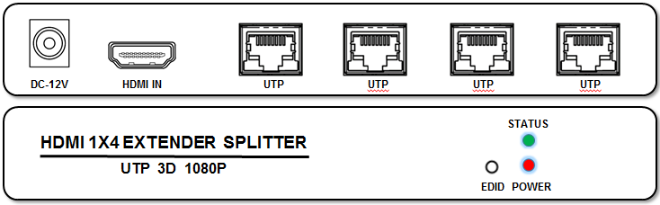

Receiver
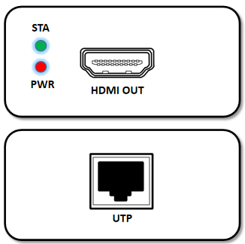

Port name | Description
HDMI IN/ HDMI OUT | HDMI signal input/ output
UTP | RJ45 network interface
EDID | ①.Plug the power supply into the "DC 12V" port of the transmitter .  ②. Use a HDMI cable connect the monitor to the transmitter.  ③. Long press the EDID button(On the transmitter ) until the STA light flashes, and then the flashing stops. Completed copy EDID.
DC 12V | Power adapter socket
LED indicator | Description
STATUS/ STA | Video signal indicator
POWER/ PWR | System power indicator

6.Installation

- Connect the provided DC 12V power supplies to the power socket of the transmitter and the receiver,
- Connect an HDMI cable between the HDMI input port of transmitter and the HDMI output port of the video source,
- Connect the HDMI output port of receiver to the display device with HDMI cable,
- Connect the transmitter RJ45 port to the receiver RJ45 port by a single CAT6 cable.

7.Diagram
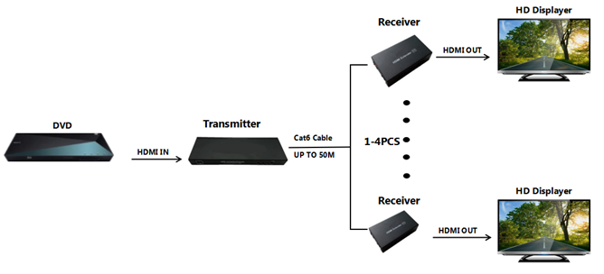

- Warranty

Please keep the user manual in a place where safety and easy to find so that you can read it immediately when meet problems.
Safety instruction:
- Please do not disassemble this product by yourself because it doesn't including DIY function.
- Please don't make the product touch water in case damaged, because it is Not waterproof design.
- Please use dry cloth material when clean the product surface.
- Please do not use this product in the environment of too wet or too high temperature.
- Please avoid contact with corrosive substances.
- When there is damage or other physical damage to the product, please stop using and contact with customer service to get support.

