HDMI 1x7 Splitter Extender
USER MANUAL

1.Description
The HDMI extender provides extension of HDMI signals long distances over a single CAT6 cable, transform one channel input to 7 channels output and 1 channel loopout. Seven of them can transmit high-definition video signals over a single CAT6 cable up to 50 meters. It supports high resolution up to 1080p and 13 kinds of EDID mode. The extender can use for a wide range of applications requiring long distance transmission of high resolution with high quality by its good stability and powerful security.

2.Features
- Transmits 1 HDMI video and audio signals up to 50M over a single CAT6 cable;
- Support video resolution up to 1920*1080@60Hz, 3D signal;
- Transform one channel HDMI input to 7 channels Cat6 signal output, 1 channel loop output;
- Support 13 EDID mode, can match many kinds of display device;
- Support bidirectional 20-60KHz IR.
- Support POC function;
- Compliance with HDMI 1.3 and HDCP 1.2 standard;
- High compatibility, can auto-match source and display device;
- Built-in automatic adjustment system, make the image smooth, clear and stable;
- Simple to install, plug and play;

3.Package list
1 pcs
7 pcs
1 pcs
7 pcs
1 pcs
1 pcs
6 pcs

        - HDMI Transmitter
        - HDMI Receiver
        - IR TX Cable
        - IR RX Cable
        - Power supply
- User manual
        - Foot Pad

4.Specifications
Parameter |  | Description
Video | Standards | HDMI 1.3; HDCP 1.2
Video | Maximum pixel clock | 165MHz
Video | Maximum data rate | 6.75Gbps
Video | Resolution | Max 1920X1080@60Hz
Video | Connector | HDMI-A
Video | Impedance | 100Ω
IR | Interface | 3.5mm earphone seat
IR | Signal direction | bidirectional direction
IR | Signal type | Digital
IR | IR frequency | 20-60KHz
Ethernet | Interface | RJ45
Ethernet | Transmission distance | CAT6---50M
Other | Power supply | The power adapter: DC 12V/2A
Other | Power dissipation | MAX 12W
Other | Temperature | Operating: -5℃ ~ +70℃
Other | Humidity | Operating: 5% ~ 90%
Other | Dimension | TX:257*87*25mm/RX:81*45*23
Other | The warranty | 1 year free warranty
5.Panel
Transmitter
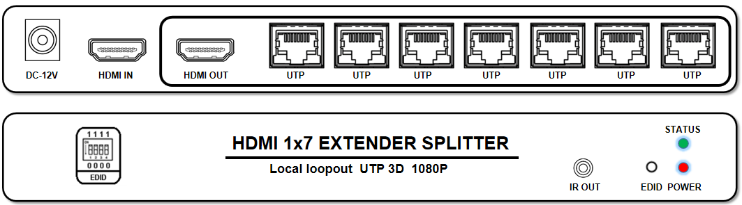

Receiver
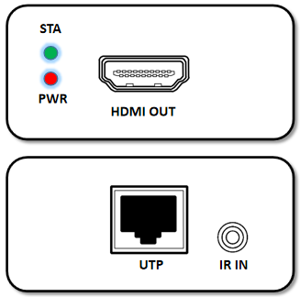
Port name | Description
HDMI IN/ HDMI OUT | HDMI signal input/ output
IR IN/IR OUT | IR signal input/output
UTP | RJ45 port connect cat6
EDID | ①.Plug the power supply into the "DC 12V" port of the transmitter.  ②. Use a HDMI cable connect the monitor to the transmitter.  ③. Long press the EDID button(On the transmitter ) until the STA light flashes, and then the flashing stops. Completed copy EDID.
DC 12V | Power adapter socket
LED indicator | Description
STATUS/ STA | Video signal indicator
POWER/ PWR | System power indicator

EDID DIP switch
0000 | Press the EDID key to learn the monitor EDID connected to the HDMI IN interface.
0001 | Open the system with auto EDID management (1080P,2CH AUDIO)
0010 | Open the system with auto EDID management (1080P,DOLBY/DTS5.1)
0011 | Open the system with auto EDID management (1080P,HD AUDIO)
0100 | Open the system with auto EDID management (1080i,2CH AUDIO)
0101 | Open the system with auto EDID management (1080i,DOLBY/DTS5.1)
0110 | Open the system with auto EDID management (1080i,HD AUDIO)
0111 | Open the system with auto EDID management (3D,1080P,2CH AUDIO)
1000 | Open the system with auto EDID management (3D,1080P,DOLBY/DTS5.1)
1001 | Open the system with auto EDID management (3D,1080P,HD AUDIO)
1010 | Reserve
1011 | Reserve
1100 | Reserve
1101 | Open the system with auto EDID management (1080P,2CH AUDIO)
1110 | Open the system with auto EDID management (1080P,2CH AUDIO)
1111 | Contrasting HDMI OUTPUT, Automatic matching EDID

6.Installation
- Connect the provided DC 12V power supplies to the power socket of the transmitter and the receiver,
- Connect an HDMI cable between the HDMI input port of transmitter and the HDMI output port of the video source,
- Connect the HDMI output port of receiver to the display device with HDMI cable,
- Connect the transmitter RJ45 port to the receiver RJ45 port by a single CAT6 cable.

7.Diagram
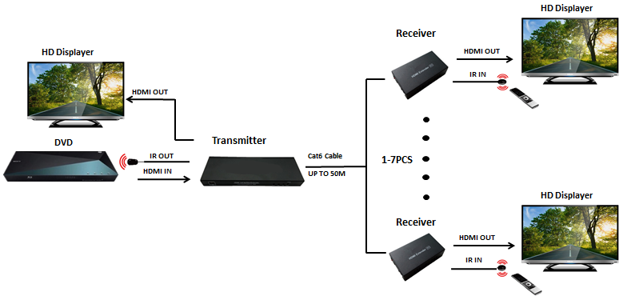

8. Warranty
Please keep the user manual in a place where safety and easy to find so that you can read it immediately when meet problems.
safety instruction:
- Please do not disassemble this product by yourself because it doesn't including DIY function.
- Please don't make the product touch water in case damaged, because it is Not waterproof design.
- Please use dry cloth material when clean the product surface.
- Please do not use this product in the environment of too wet or too high temperature.
- Please avoid contact with corrosive substances.
- When there is damage or other physical damage to the product, please stop using and contact with customer service to get support.

